Scholarship announcements in Rep. Council Packets  Scholarship applications available on www.sdea.net | Wednesday, December 13, 2017
DEADLINE - Scholarships due to SDEA office  Attn: Lisa Steinberg | Friday, May 4, 2018 - no later than 5:00 p.m.
Scholarships read by panel | Monday, May 7 – Friday, May 11, 2018
Scholarships returned to SDEA from panel | Friday, May 11 – Friday, May 18, 2018
Scholarships awarded by panel | Friday, May 18, 2018
Notices sent out to applicants | Monday, May 21, 2018
Scholarship presented at June Rep. Council | Wednesday, June 6, 2018 @ 4:00 p.m.
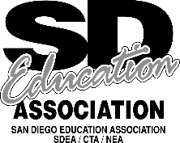
Contact SDEA for a scholarship application at (619) 283-4411 or download a copy from the SDEA website www.sdea.net

