SDEA Fall Special Election 2012
 |  |  | Teller's Report
 | Board of Directors
 | Seat 4
Total Ballots Received | 94
Subtract Illegal | 0
Subtract blank | 1
Total legal ballot cast | 93
# to Win (half cast plus 1) | 48
 | Weimer _____55
 | Padilla_______38
 | Write-In----0
 | CTA State Council
 | Seat 15
Total Ballots Received | 592
Subtract Illegal | 27
Subtract blank | 7
Total Legal Ballot cast | 559
#r to win (half cast plus 1) | 281
 | Legler____171 | RUNOFF
 | Burnigham__235 | RUNOFF
 | Mullin______137
 | Write-in-----16
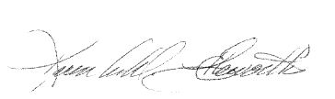
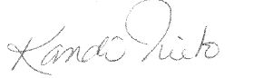

_________________________ |  | __________________________
Election Committee Co-Chair |  | Election Committee Co-Chair

